Carlos Lopez

Dr. Cannon

KHC ST112

21 April 2020

**The Relevance of *Philadelphia* in our modern-day society**

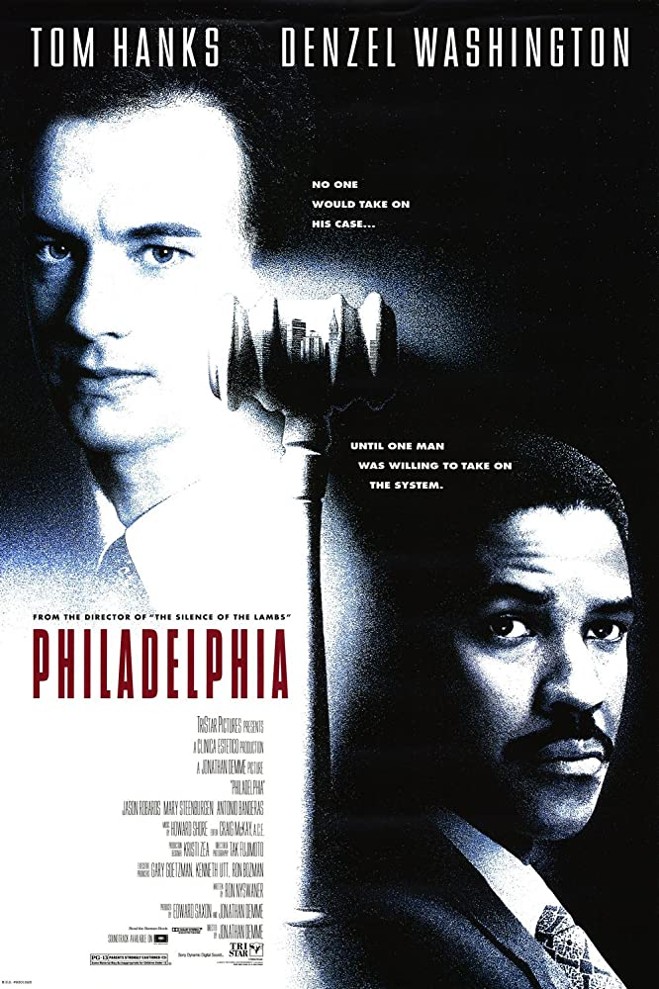

IMDb *Philadelphia*

They say that those who do not learn from history are doomed to repeat it, and I think we can all agree that the citizens of the United States have made mistakes in the past that we hope will never happen again. Take for example the persecution of the LGBT community back during the 1980’s, due to the AIDS pandemic and misconceptions regarding the disease’s transmission. Not only was the general population terrified, but many of the people suffering from this disease denied themselves of the proper medical care to avoid the stigma and discrimination that came with AIDS. To avoid these unnecessary deaths, several campaigns were made to spread information regarding the disease and the people suffering from it, so as to end this discrimination and ignorance. It was for this reason that the critically acclaimed movie *Philadelphia* was released on theaters in 1993 with the aim to reach a larger audience through the use of film. The movie became a success winning two Oscars and earning more than $100 million in box office sales(Gordon). More importantly, it seems to have achieved its goal of making the general public more informed, but now that it has been almost 30 years, the HIV virus is widely known, and the disease has become treatable. Hence, I ask what can we still learn from watching the film? Is it even culturally relevant anymore, especially now that we are faced with another pandemic, COVID-19?As it turns out, *Philadelphia* is still capable of teaching relevant lessons that contemporary viewers can apply to our current health crisis.

The first relevant lesson, and simultaneously the most prominent one, that can be derived from this movie is that prejudice often arises from ignorance and lack of exposure to the victim. Throughout the film, we follow two main characters: Andrew Beckett (played by Tom Hanks) who was just fired from his job based on his disease, and Joe Miller (played by Denzel Washington) who becomes his lawyer to help him get justice. However, the audience is not meant to associate with the victim of the injustice. According to Monica B. Pearl, “the fundamental audience identification will be with those characters who are ambivalent or intolerant of AIDS and homosexuality, not those who are gay, infected, and ill.” After all, those people are already aware of how bad their situation is, and they are not who the film was made for. The film was intended to make the oppressors question their actions and beliefs by watching what they believe in from an outsider’s perspective. “if we are mean and closed-minded, or even just ambivalent about homosexuality, we identify with Joe Miller (Denzel Washington), who is homophobic and taught over the film’s narrative to be a little less so.” (Pearl) In other words, from the very beginning of the movie the intended audience is meant to identify with a character who through prejudice, despises gay men. As a matter of fact, Joe Miller does not want to take Andrew Beckett’s case at first, to quote him in the film: “Would you accept a client if you were constantly thinking ‘I don’t want this person to touch me. I don’t want him to even breathe on me.’” (IMDb) He asks this to his wife, but the quote is so direct he might as well be addressing the audience. However, through enough exposure to Andrew Beckett, he starts realizing that his viewpoint is flawed not only because the disease does not transmit as easily as he thinks it does, but because he genuinely starts liking Andrew Beckett and admires his cause. Hence, it is through the course of watching the movie that the audience begins to understand that the reasons that motivate Joe Miller to dislike Andrew Beckett and homosexuals in general are based in misconceptions and are supposed to see that maybe their own arguments for hating homosexuals aren’t that sound.

Similarly, there has been a recent xenophobic attitude springing up against Asian Americans lately due to the coronavirus. At the time of writing this paper, the topic of COVID-19 or corona-virus, as it is currently more commonly referred to, is quite present in the United States since it has caused a mass stay-home quarantine and is currently shy of 800,000 reported cases world-wide, and much like the HIV virus, it has caused quite the panic. In addition, it has taken plenty of lives already and the death toll is only expected to rise in the coming weeks. This virus originated in Wuhan, China but the reason that most people blame China for this crisis and anyone that looks remotely related to it, is the negligence of the Chinese government when reporting this virus. (Kwong) It is due to all this tension and stress that several American citizens are repeating the mistakes from the past and are becoming discriminatory to this group of people, and Asian Americans are scared in response. You can really see the parallels when you start comparing what the people from now are saying and what the people from then said. 34-year-old Lang Nguyen reports the reaction of the surrounding people when he choked on a sip of water “The woman [in front of me] happened to turn around and say if you’re going to be sick you might want to stay home[…]She said some racial slur to me like, ‘All you Asian people are spreading that coronavirus’ and so forth.”(Myong) In the other hand, here are some words by Michael Penn, a gay man who lived through the crisis of the 1980’s: “People were ignorant. There was nothing known about the disease. No one knew how to treat it. The ordinary man in the street was very suspicious if he knew you were gay. I remember after Brian died, I went to local pub and the publican in my hearing said to someone 'don’t let anyone drink out of that glass'. I was furious.” (Gander) Similarly, both diseases had their corresponding names associated with the type of minority discriminated. Some individuals during the 1980’s referring to AIDS as “gay cancer” (Wright) and nowadays people, including president Trump, are calling COVID-19 “the Chinese Flu” or more commonly “the Chinese Virus.” Hence, it seems intuitive to believe that reflecting or maybe even re-reflecting on a movie like *Philadelphia* would cause similar results and realizations on the general public regarding the base-less stigma around Asian-Americans. However, I’ll admit that this won’t eradicate the stigma completely. After all, there are people still misinformed holding strongly to their homophobic beliefs. Simply, look at these quotes that the Gay Men’s Health Crisis (GMHC) organization received when polling on sentiments towards HIV/AIDS back in 2006-2007: “Fags are to blame.” “Go enjoy your self-inflicted disease” “If you guys would stop butt f**king each other, you wouldn’t have a problem.” However, these opinions are not as widespread anymore and some of that credit can be attributed to *Philadelphia.*

The second big lesson that can be learned is that during hard times the right amount of communication and quality of information is key. Three or four decades ago, not only was sexual orientation in general not really talked about, but HIV/AIDS was a taboo topic. Hence, you need to realize that despite certain actions seeming bad in retrospective like extreme distrust and fear of touching people suffering from the disease, these actions are only natural when you don’t know what you are facing. *Philadelphia* managed to break this silence. Gary Bell, who has advocated for HIV awareness through a health service agency in Philadelphia for decades, recalls that “I remember there was quite a buzz about it[…]I think the good news was that it got people talking about HIV in a way that they really weren’t, because HIV was always that thing we really didn’t want to talk about.”(Gordon) As a matter of fact, the Center for Disease Control (CDC) cites talking about HIV as a main response to get rid of HIV stigma “Talking openly about HIV can help normalize the subject. It also provides opportunities to correct misconceptions and help others learn more about HIV. But be mindful of how you talk about HIV and people living with HIV,” and today the CDC cites something similar for getting rid of the stigma associated with the coronavirus “Share accurate information about how the virus spreads,” “Speak out against negative behaviors, including negative statements on social media about groups of people, or exclusion of people who pose no risk from regular activities,” and “Be cautious about the images that are shared. Make sure they do not reinforce stereotypes.” As you can see, the diffusion of information is still important. However, if you look closely at the wording for the guide on how to reduce stigma on coronavirus, you’ll notice certain keywords like “accurate” or “negative statements.” In the 1980’s only big companies and the media had the power of influencing the masses through television and advertisements, but now that everyone has a phone, the problem is no longer that people are keeping to themselves. The problem now is that there is so much information online that people do not know what to trust anymore. Anyone with a phone can go online and say whatever they please and often times this creates panic and tension among the public. Take for example the document below regarding the mobilization of the national guard to enforce the closing of all businesses for a two-week quarantine which was circulating social media very recently.

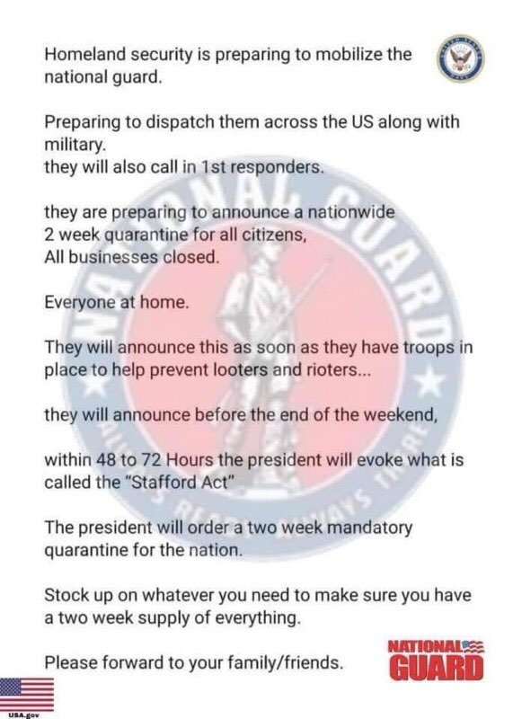

KRQE News *National Guard Warns about Fraudulent Social Media Post.*

Hence, the themes of misinformation and communication touched on by the movie are relevant more than ever, but rather than concerning about the lack of communication, we can see that the problem has shifted to the quality of information that comes from it.

One final lesson that comes from the movie and the situation surrounding it is that eventually, this too will pass. In retrospect, this movie can really serve as a testament to how far we have come since the peak of the epidemic. During the time that the movie is set in, tensions were high, and an entire community was being segregated and discriminated against, but since then the disease has become treatable. Medications like pre-exposure prophylaxis exist and have become more available than ever, and on March 10, 2020 a second patient was completely cured of HIV due to the cutting-edge research that is currently being done on stem cell transplants (Cohut). In addition, ignorance regarding the HIV virus has become rarer due to organizations that raise awareness for it like HIV.gov. Similarly, despite things looking pretty bleak right now, the United States is taking steps in the right direction to end this crisis as soon as possible. Testing is becoming more available to those who need it, the Coronavirus Relief Bill was recently passed which will provide an ample sum of money to every American family to help with whatever financial problems they might face due to this crisis, and people are starting to understand that the best way to limit the spread of the virus is to practice social distancing and self-isolation for a while (whitehouse.gov).

Overall, the movie *Philadelphia* has lasted the test of time as a classic that shows us how ignorance and panic in a time of crisis can divide us. In addition, the lessons that it left us with can still be reflected upon and applied to society today, so that similar mistakes and injustices as those committed in the past do not repeat. In fact, we can already start seeing some familiar patterns in this new COVID-19 pandemic that we are facing such as the baseless discrimination of a group of people due to fear and need to point the finger at someone. However, we can also see how due to us learning from the past and changing over time some problems have already been avoided or transformed such as how information on the disease is no longer scarce, but due to its high supply, it can sometimes be overwhelming and misleading. Despite that, seeing these patterns helps us better prepare for the future, and can give us a glimmer of hope to know that similar situations have already happened before and the world managed to make it through, so why would we not be able to make it through one more time?

**Bibliography**

Brown, Timothy Ray. “I Am the Berlin Patient: a Personal Reflection.” *AIDS Research and Human Retroviruses*, Mary Ann Liebert, Inc., Jan. 2015, www.ncbi.nlm.nih.gov/pmc/articles/PMC4287108/.

“Facts about HIV Stigma.” *Centers for Disease Control and Prevention*, Centers for Disease Control and Prevention, 27 Sept. 2019, www.cdc.gov/hiv/basics/hiv-stigma/index.html.

Gander, Kashmira. “The Terrifying Experiences of a Gay Man Who Lived through the AIDS Crisis.” *The Independent*, Independent Digital News and Media, 6 Jan. 2017, www.independent.co.uk/life-style/love-sex/aids-crisis-1980-eighties-remember-gay-man-hiv-positive-funerals-partners-disease-michael-penn-a7511671.html.

Gordon, Elana. “Two Decades Ago, Tom Hanks and 'Philadelphia' Prompted Changing Attitudes Toward HIV-AIDS.” *NBC10 Philadelphia*, NBC 10 Philadelphia, 20 Dec. 2013, www.nbcphiladelphia.com/news/local/two-decades-ago-tom-hanks-and-philadelphia-prompted-changing-attitudes-toward-hiv-aids/2082289/.

KRQE “National Guard Warns about Fraudulent Social Media Post.” *KRQE News 13*, 27 Mar. 2020, www.krqe.com/health/coronavirus-new-mexico/national-guard-warns-about-fraudulent-social-media-post/.

Kwong, Emily. “Where Did This Coronavirus Originate? Virus Hunters Find Genetic Clues In Bats.” *NPR*, NPR, 15 Apr. 2020, www.npr.org/2020/04/14/834109166/where-did-the-coronavirus-originate-virus-hunters-find-genetic-clues-in-bats.

Maria Cohut, Ph.D. “2nd Person Cured of HIV Thanks to Stem Cell Transplant.” *Medical News Today*, MediLexicon International, www.medicalnewstoday.com/articles/2nd-person-cured-of-hiv-thanks-to-stem-cell-transplant#Success-of-stem-cell-transplantation.

Myong, Elizabeth. “'A Spike In Prejudice': DFW Asian-Americans Share Stories Of Racism As Coronavirus Rolls In.” *KUT*, 25 Mar. 2020, www.kut.org/post/spike-prejudice-asian-americans-dfw-face-racism-coronavirus-spreads.

“Philadelphia.” *IMDb*, IMDb.com, 14 Jan. 1994, www.imdb.com/title/tt0107818/.

Podolsky, Brett A. “Law Office of Brett A. Podolsky.” *Brett A. Podolsky*, 3 Nov. 2017, brettpodolsky.com/general-law/3-important-lessons-from-the-movie-philadelphia.

“President Donald J. Trump Has Taken Unprecedented Steps To Respond To The Coronavirus And Protect The Health And Safety Of Americans.” *The White House*, The United States Government, www.whitehouse.gov/briefings-statements/president-donald-j-trump-taken-unprecedented-steps-respond-coronavirus-protect-health-safety-americans/.

“Reducing Stigma.” *Centers for Disease Control and Prevention*, Centers for Disease Control and Prevention, 21 Mar. 2020, www.cdc.gov/coronavirus/2019-ncov/daily-life-coping/reducing-stigma.html?CDC_AA_refVal=https://www.cdc.gov/coronavirus/2019-ncov/symptoms-testing/reducing-stigma.html.

Wright, Joe. “Remembering the Early Days of 'Gay Cancer'.” *NPR*, NPR, 8 May 2006, www.npr.org/templates/story/story.php?storyId=5391495.